Name: Chou Cheuk Yin

UID: 3035569691

COMP3278 Project report

**Topic:** Library Management System

**Brief Description:**

A system for the library management to keep track of information of libraries, book status and library card holder status, in addition to standard enterprise information such as human resources and accounting.

**Business Rules:**

* The top layer of library management called Library Management Centre here, can be divided into separate libraries.
* Libraries are identified by their unique ID. Each library has a location as its name, and item amount.
* The Library Management Centre has a list of staff. Each staff is associated with him a unique staff ID, name, identity card number, address, email, phone number, library ID, position, join date, and salary.
* The Library Management Centre also has a list of their storage. Each item is identified by their unique item ID, and has ISBN, bought date, cost, library ID, and status. Its other data is stored in Collection, with ISBN, name, type (book, CD, etc.), author, publisher, language, search ID, and category.
* Books or CD can have the same name and search ID if they are the same book/CD, but must have different item ID.
* Library card holders (members) are identified by their unique ID. Each of them has name, identity card number, address, and penalty.
* Library card holders has a list of items borrowed, maximum 6 slots. Each slot has a slot ID, an item ID of the borrowed item, borrowed date and return date.

**Assumptions:**

* Other information of libraries, such as opening time etc. are assumed consistent throughout libraries and unimportant to the system and thus are not included. There are no mobile libraries.
* Books/CDs and human resources are distributed through The Library Management Centre.
* Return date of book can be extended.
* Books/CDs must be returned to their original library before they can be borrowed again. Users can return an item to any library, but it will be in a status called “delivering” before returning to its original library.
* Assume that CD uses ISBN also.

**System functionalities/user activities:**

* List all items. It can be sorted/filtered by ID/type/library/category etc.
* List all staff. It can be sorted/filtered by ID/library/position/salary etc.
* Find specific item through searching name/ID/ISBN.
* etc.

**Data requirement analysis:**

**Library** (M/O = Mandatory/Optional)

|  |  |  |
| --- | --- | --- |
| **Attribute Name** | **Description** |  |
| ID_library | Unique ID of library | |  |  | | --- | --- | | M/O | Mandatory | | Type | char | | Length | 3 | | Format |  | | Validation |  | | Default |  | | Example | 001 | |
| Location | Location of library.  Also name of library. | |  |  | | --- | --- | | M/O | Mandatory | | Type | varchar | | Length | 20 | | Format |  | | Validation |  | | Default |  | | Example | Tsuen Wan | |
| item_amount | Total amount of items of library | |  |  | | --- | --- | | M/O | Mandatory | | Type | int | | Length |  | | Format |  | | Validation | >=0 | | Default |  | | Example | 5894 | |

**Staff**

|  |  |  |
| --- | --- | --- |
| **Attribute Name** | **Description** |  |
| ID_staff | Unique ID of staff | |  |  | | --- | --- | | M/O | Mandatory | | Type | char | | Length | 5 | | Format |  | | Validation |  | | Default |  | | Example | 00001 | |
| name | name of staff | |  |  | | --- | --- | | M/O | Mandatory | | Type | varchar | | Length | 30 | | Format |  | | Validation |  | | Default |  | | Example | Chris Wong | |
| card_ID | ID card no. of staff | |  |  | | --- | --- | | M/O | Mandatory | | Type | char | | Length | 8 | | Format |  | | Validation |  | | Default |  | | Example | A1234567 | |
| address | address of staff | |  |  | | --- | --- | | M/O | Mandatory | | Type | varchar | | Length | 200 | | Format |  | | Validation |  | | Default |  | | Example | Flat A, 3/F, Block A, XX Gardens, XX Nathan Road, Mong Kok | |

|  |  |  |  |  |  |  |  |  |  |  |  |  |  |  |  |  |
| --- | --- | --- | --- | --- | --- | --- | --- | --- | --- | --- | --- | --- | --- | --- | --- | --- |
| email | email of staff | |  |  | | --- | --- | | M/O | Mandatory | | Type | varchar | | Length | 30 | | Format |  | | Validation |  | | Default |  | | Example | a@gmail.com | |
| phone | phone no of staff | |  |  | | --- | --- | | M/O | Mandatory | | Type | char | | Length | 8 | | Format |  | | Validation |  | | Default |  | | Example | 98765432 | |
| ID_library | library ID of staff | |  |  | | --- | --- | | M/O | Mandatory | | Type | char | | Length | 3 | | Format |  | | Validation |  | | Default |  | | Example | 001 | |
| position | position of staff | |  |  | | --- | --- | | M/O | Mandatory | | Type | varchar | | Length | 20 | | Format |  | | Validation |  | | Default |  | | Example | Book manager | |
| join_date | join date of staff | |  |  | | --- | --- | | M/O | Mandatory | | Type | date | | Length | 10 | | Format | dd/mm/yyyy | | Validation |  | | Default |  | | Example | 01/08/2014 | |

|  |  |  |  |  |  |  |  |  |  |  |  |  |  |  |  |  |
| --- | --- | --- | --- | --- | --- | --- | --- | --- | --- | --- | --- | --- | --- | --- | --- | --- |
| salary | salary of staff | |  |  | | --- | --- | | M/O | Mandatory | | Type | numeric | | Length | (7,1) | | Format |  | | Validation | >0 | | Default |  | | Example | 123456.7 | |

**Collection**

|  |  |  |
| --- | --- | --- |
| **Attribute Name** | **Description** |  |
| ISBN | ISBN of items | |  |  | | --- | --- | | M/O | Mandatory | | Type | char | | Length | 13 | | Format |  | | Validation |  | | Default |  | | Example | 9788175257665 | |
| name | name of items | |  |  | | --- | --- | | M/O | Mandatory | | Type | varchar | | Length | 100 | | Format |  | | Validation |  | | Default |  | | Example | Life of Pi | |
| type | type of items | |  |  | | --- | --- | | M/O | Mandatory | | Type | char | | Length | 2 | | Format |  | | Validation |  | | Default |  | | Example | 01 | |
| author | author of items | |  |  | | --- | --- | | M/O | Optional | | Type | varchar | | Length | 50 | | Format |  | | Validation |  | | Default |  | | Example | Ray Chan | |
| publisher | publisher of items | |  |  | | --- | --- | | M/O | Optional | | Type | varchar | | Length | 50 | | Format |  | | Validation |  | | Default |  | | Example | Ape Publisher Ltd | |
| language | language of items | |  |  | | --- | --- | | M/O | Mandatory | | Type | varchar | | Length | 20 | | Format |  | | Validation |  | | Default |  | | Example | English | |
| ID_search | search ID of items | |  |  | | --- | --- | | M/O | Mandatory | | Type | char | | Length | 7 | | Format |  | | Validation |  | | Default |  | | Example | 857 4038 | |
| category | category of items | |  |  | | --- | --- | | M/O | Mandatory | | Type | varchar | | Length | 20 | | Format |  | | Validation |  | | Default |  | | Example | Novel | |

**Item**

|  |  |  |
| --- | --- | --- |
| **Attribute Name** | **Description** |  |
| ID_item | Unique ID of items | |  |  | | --- | --- | | M/O | Mandatory | | Type | char | | Length | 10 | | Format |  | | Validation |  | | Default |  | | Example | 010 234 5678 | |
| ISBN | ISBN of items | |  |  | | --- | --- | | M/O | Mandatory | | Type | char | | Length | 13 | | Format |  | | Validation |  | | Default |  | | Example | 9788175257665 | |
| ID_library | ID of belonging library of items | |  |  | | --- | --- | | M/O | Mandatory | | Type | char | | Length | 3 | | Format |  | | Validation |  | | Default |  | | Example | 001 | |
| bought_date | bought date of items | |  |  | | --- | --- | | M/O | Mandatory | | Type | date | | Length | 10 | | Format | dd/mm/yyyy | | Validation |  | | Default |  | | Example | 23/05/2008 | |
| cost | cost of items | |  |  | | --- | --- | | M/O | Optional | | Type | numerical | | Length | (4,1) | | Format |  | | Validation |  | | Default |  | | Example | 128.5 | |
| status | status of items | |  |  | | --- | --- | | M/O | Mandatory | | Type | char | | Length | 2 | | Format |  | | Validation |  | | Default |  | | Example | 01 | |

**Library card holder(member)**

|  |  |  |  |  |  |  |  |  |  |  |  |  |  |  |  |  |
| --- | --- | --- | --- | --- | --- | --- | --- | --- | --- | --- | --- | --- | --- | --- | --- | --- |
| ID_member | Unique ID of members | |  |  | | --- | --- | | M/O | Mandatory | | Type | char | | Length | 10 | | Format |  | | Validation |  | | Default |  | | Example | 925 364 4578 | |
| name | name of mambers | |  |  | | --- | --- | | M/O | Mandatory | | Type | varchar | | Length | 30 | | Format |  | | Validation |  | | Default |  | | Example | Chan Tai Man | |
| card_ID | ID card no. of members | |  |  | | --- | --- | | M/O | Mandatory | | Type | char | | Length | 8 | | Format |  | | Validation |  | | Default |  | | Example | B9876543 | |
| penalty | penalty of members, i.e. how much they need to pay when they did not return item on time/broke a book etc. | |  |  | | --- | --- | | M/O | Mandatory | | Type | numerical | | Length | (4,1) | | Format |  | | Validation | >=0 | | Default | 0 | | Example | 15.4 | |
| address | address of members | |  |  | | --- | --- | | M/O | Mandatory | | Type | varchar | | Length | 200 | | Format |  | | Validation |  | | Default |  | | Example | Flat B, 4/F, Block E, XX Gardens | |

**Slot**

|  |  |  |  |  |  |  |  |  |  |  |  |  |  |  |  |  |
| --- | --- | --- | --- | --- | --- | --- | --- | --- | --- | --- | --- | --- | --- | --- | --- | --- |
| ID_slot | ID of slots | |  |  | | --- | --- | | M/O | Mandatory | | Type | char | | Length | 11 | | Format |  | | Validation |  | | Default |  | | Example | 6 | |
| ID_item | ID of borrowed items | |  |  | | --- | --- | | M/O | Optional | | Type | char | | Length | 10 | | Format |  | | Validation |  | | Default |  | | Example | 010 234 5678 | |
| borrow_date | borrowed date of items | |  |  | | --- | --- | | M/O | Optional | | Type | date | | Length | 10 | | Format |  | | Validation |  | | Default |  | | Example | 09/10/2020 | |
| return_date | return date of items | |  |  | | --- | --- | | M/O | Optional | | Type | date | | Length | 10 | | Format |  | | Validation |  | | Default |  | | Example | 23/10/2020 | |

**ER Model Diagram:** 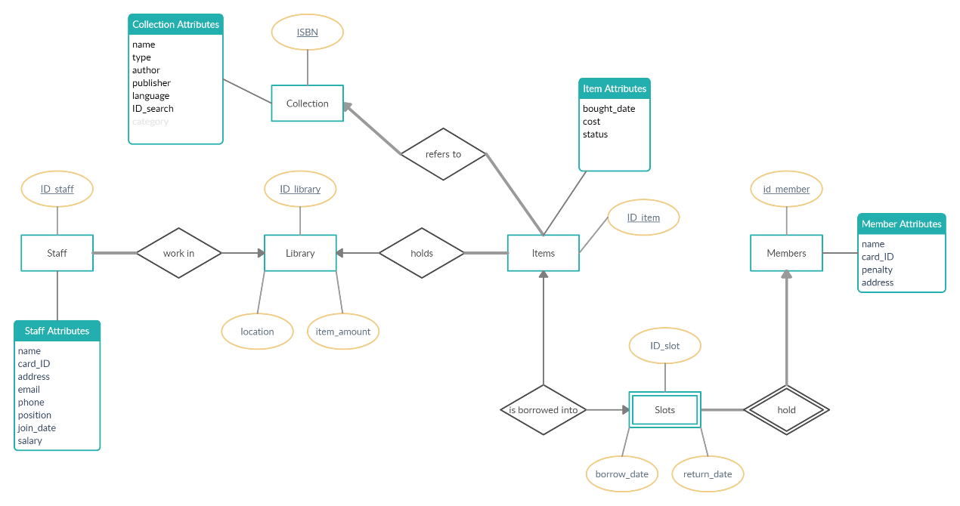

**ER diagram description:**

*Total Participation is denoted with think lines while partial is denoted with thin lines.*

*Derived attributes are derived with pale grey font colour.*

* Each staff belongs to one and only one library. (Total participation)
* Each item belongs to one and only one library. (Total participation)
* A library has zero to many staff, and zero to many books.  
  (Partial participation)
* Each item can be borrowed by zero to one member.   
  (Partial participation)
* Each item can be of one and only one collection. (Total participation)
* Each collection can be of one or more items. (Total participation)
* Each member can borrow zero to six items.   
  (Partial participation)
* Each slot can fit in zero to one item.  
  (Partial participation)
* Each item can be in zero or one slot.   
  (Partial participation)
* Each slot is owned by one and only one member.  
  (Total participation)
* Each member has six slots.  
  (Total participation)

**Relational Database Schema:**

Library(ID_library, location, item_amount)

Staff(ID_staff, ID_library, name, card_ID, address, email, phone, position, join_date, salary)

* Foreign key: {ID_library} references Library(ID_library)

Collection(ISBN, name, type, author, publisher, language, ID_search, category)

Item(ID_item, ID_library, ISBN, bought_date, cost, status)

* Foreign key: {ID_library} references Library(ID_library)
* Foreign key: {ISBN} references Collection(ISBN)

Member(ID_member, name, card_ID, penalty, address)

Slot(ID_member, ID_slot, ID_item, borrow_date, Return_date)

* Foreign key: {ID_member} references Member(ID_member)

{ID_item} references Item(ID_item)

**Queries:**

Q1: List all libraries.

Q2: List all staff with criteria. Example criteria are:

1. from library with ID=4;
2. with salary>50000;
3. with join date later than 2011-01-01, ordered by join date;
4. with position “Accounting Assistant”.

Q3: List all members. Example criteria is with penalty larger than 0.

Q4: List all collection with specified language (e.g. Chinese).

Q5: List the library location, all Item ID, ISBN, names, and status with location “Jinnan”, ordered by status then ISBN

Q6: List all library location, Item ID, ISBN, names, and status with collection name “Unthinkable”, ordered by status.

Q7: List all library location, Item ID, ISBN, names, and status with type = 1(books), ordered by ISBN then status.

Q8: List all library location, Item ID, ISBN, names, and status with category “Drama”, ordered by ISBN then status.

Q9: List all slots of a member, displaying member ID, name, Slot ID, and collection name (name of item borrowed). Ordered by slot ID. Shows *NULL* for unoccupied slots. Example is with ID=35.

Q10: List all member ID, name, member ID card, Slot ID, collection name, borrow date and return date with return date before 2020-11-20, ordered by member ID then slot ID. This is for the library to check for expiry.

Q11: List all library ID, location, item amount and count the total of books of that library. For checking purposes.

Q12: List all member ID, names and count the number of empty slots. If all slots are full, *NULL* will be displayed.

Q13: List all member ID and names for members who is not borrowing a book at the moment.

Q14: List all member ID and names for member who borrowed the item “Houseboat”. Shows ISBN and collection name for checking purposes.

Q15: Simulating a recommendation of a random book/CD. Display library locations, item ID, ISBN, collection name and status of an item randomly selected.